**A9Wm Linear Regression and Durbin-Watson Test for Serial Correlation**

To fit a linear regression model to data pairs (x, y) the assumptions are:

1. Assumption of normality – required to undertake hypothesis testing and to fit confidence intervals to data.
2. The error terms in linear regression have mean zero, constant variance, and uncorrelated.

A key assumption is that the error terms are uncorrelated (or independent) of each other. In this guide, we present a simple test to determine whether there is autocorrelation (aka serial correlation), i.e. where there is a (linear) correlation between the error term for one observation and the next. This is especially relevant with time series data where the data are sequenced by time. Regression models using time series data occur relatively often in economics and business.

In statistics, the Durbin–Watson statistic is a test statistic used to detect the presence of autocorrelation in the residuals from a regression analysis. It is named after James Durbin and Geoffrey Watson. A similar assessment can be also carried out with the Breusch–Godfrey test and the Ljung–Box test.

Note that the Durbin-Watson test measures only the first order serial correlation. It does not provide the measurement for higher order serial correlations, which is why we differentiate it from the general autocorrelation function measurement. We will demonstrate below how the Durbin-Watson test is linked with the first order autocorrelation coefficient.

**Durbin-Watson test**

A common kind of autocorrelation, sometimes called **serial autocorrelation**, is one in which the error term in the current time period is directly related to the error term in the previous time period. The regression equation can be written as given in equation (1):

Yt = β0 + β1 Xt + et (1)

with the error term et defined by equation (2):

et = ρ et-1 + vt (2)

where

et = the error at time t

ρ = the lag 1 autocorrelation coefficient that measures correlation between adjacent error terms.

Vt = the normally distributed independent error term with mean zero and variance σ2v.

Equation (2) says that the level of one error term (et-1) directly affects the level of the next error term (et). The size of the autocorrelation coefficient, ρ, where -1 ≤ ρ ≤ +1, indicates the strength of the serial correlation. If ρ = 0, then there is no serial correlation, and the error terms are independent (et = vt).

A test for significant autocorrelation, known as the Durbin-Watson test, determines whether the autocorrelation parameter, ρ, is zero in equation (2). Because most regression problems involving time series data exhibit positive autocorrelation, the hypothesis usually considered in the Durbin-Watson test are:

H0: ρ ≤ 0

H1: ρ > 0

where ρ (Greek letter rho) represents the population correlation value. It is possible to have negative autocorrelation (very rare) or even a two sided hypothesis test.

If et is the residual associated with the observation at time t, then the test statistic is

$$\text{d= }\frac{\sum_{\text{i=2}}^{\text{n}}{{\left({\text{e}}_{\text{t}}\text{- }{\text{e}}_{\text{t-1}}\right)}^{\text{2}}}}{\sum_{\text{t=1}}^{\text{n}}{{\text{e}}_{\text{t}}^{\text{2}}}}$$

Where $e_{t}= y_{t}- {\hat{y}}_{t}$, and $y_{t}$, ${\hat{y}}_{t}$ are, respectively, the observed and predicted values of the response variable for individual i.

For the null hypothesis to be true then the mathematical analysis behind the Durbin-Watson test shows that the value of the statistic should be equal to the value 2. If d = 2, then the null hypothesis is accepted, and we say that we have no evidence of autocorrelation in the regression model.

The value of d always lies between 0 and 4.

If the Durbin–Watson statistic is substantially less than 2, there is evidence of positive serial correlation. As a rough rule of thumb, if Durbin–Watson is less than 1.0, there may be cause for alarm. Small values of d indicate successive error terms are, on average, close in value to one another, or **positively correlated**. If d > 2, successive error terms are, on average, much different in value from one another, i.e., negatively correlated.

In Chapter 10 we introduced the autocorrelation function and demonstrated how the coefficients that constitute this function are calculated. If we lag the variable by just one period, we get the **first autocorrelation coefficient**, called the **first order autocorrelation coefficient or ρ1**. It can be shown that the relationship between the first order autocorrelation coefficient, ρ1, and the Durbin-Watson coefficient, d, is defined by equation (3):

D = 2 (1 - ρ1) (3)

Where, if:

ρ1 = 0, then d = 2

ρ1 = 1, then d = 0

ρ1 = -1, then d = 4

As we can see, this confirms that the value of d should be between 0 and 4 and why specifically if d = 2, there is no evidence of autocorrelation (ρ1 = 0).

To test for positive autocorrelation at significance α [H0: ρ ≤ 0, H1: ρ > 0]

The test statistic d is compared to lower and upper critical values (dL and dU) for a value of significance α

* If d < dL, then we conclude that the autocorrelation coefficient, ρ, is greater than zero [there is statistical evidence that the error terms are positively autocorrelated].
* If d > dU, then we conclude that the autocorrelation coefficient, ρ, is zero [there is no statistical evidence that the error terms are positively autocorrelated]
* If dL < d < dU, the test is inconclusive and we cannot conclude that there is positive autocorrelation.

Positive serial correlation is serial correlation in which a positive error for one observation increases the chances of a positive error for another observation.

To test for negative autocorrelation at significance α [H0: ρ ≥ 0, H1: ρ < 0]

The test statistic, d, is compared to 4 - dL and 4 - dU.

* If d > 4 - dL, conclude negative autocorrelation.
* If d < 4 - dU, conclude there is no statistical evidence that the error terms are negatively autocorrelated.
* If d lies between 4 – du and 4 – du then the test is inconclusive.

Negative serial correlation implies that a positive error for one observation increases the chance of a negative error for another observation and a negative error for one observation increases the chances of a positive error for another.

Critical Durbin-Watson test values

The critical values, dL and dU, vary by level of significance (α), the number of observations, and the number of predictors in the regression equation. Their derivation is complex—statisticians typically obtain them from statistical tables. Figure 1 illustrates a screenshot of a table representing the Durbin-Watson critical values.

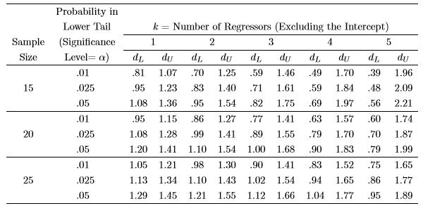

Figure 1 Critical values of the Durbin-Watson test statistic

For example, if we have a regression equation with one predictor variable (k = 1), the number of sample points (x, y) is 20 (n = 20), and we wish to measure at a 5% lower tail critical value (α = 0.05). Then, we have α = 0.05, k = 1 and n = 20, and the lower and upper critical values from Figure 1 are dL = 1.20 and dU = 1.41.

Examples – using dL = 1.20 and dU = 1.41.

Say, we are testing for positive autocorrelation, H1: ρ > 0

1. If we find that the sample test statistic d = 1.08, then d < DL (= 1.08 < 1.20), and we conclude that the errors are positively autocorrelated.
2. If we find that the sample test statistic d = 1.60, then d > Du (= 1.60 > 1.41), and we conclude that there is no evidence to suggest errors are positively autocorrelated.
3. If we find that the sample test statistic d = 1.31, then d = 1.31 lies between the lower and upper critical values (1.20 < 1.31 < 1.41), and we conclude the test is inconclusive in the sense that you are looking for positive autocorrelation, and this result tells us that statistically the evidence suggests no positive autocorrelation or insufficient sample results available to provide a result to accept that positive autocorrelation exists.

**What do we do if we find serial autocorrelation (first order autocorrelation)?**

If autocorrelation is discovered then one possible solution is to modify the regression model to remove the autocorrelation. Possible methods includes incorporating a missing variable into the regression model or undertaking some form of differencing on the regression equation. These topics are beyond the scope of this text book.

**Large sample normal approximation for Durbin-Watson critical values**

If the sample size, n, is large (>50+, please note no acceptable value for n when n can be considered large) then can use a normal approximation for the DW statistic, d, with mean = 2 and variance = 4/n.

**Data Example**

Consider the data presented in Table 1 that explores the annual sales of a soft drink against annual expenditure for 20-time points. Based upon this data we wish to fit a linear regression model to predict the annual sales based upon one predictor variable, the annual spend on advertising. Furthermore, we wish to test for positive autocorrelation (H1: ρ > 0).

|  |  |  |
| --- | --- | --- |
| Time point | Annual Number of Sales (units), y | Annual Advertising Expenditure (£ x 1000), x |
| 1 | 3083 | 75 |
| 2 | 3149 | 78 |
| 3 | 3218 | 80 |
| 4 | 3239 | 82 |
| 5 | 3295 | 84 |
| 6 | 3374 | 88 |
| 7 | 3475 | 93 |
| 8 | 3569 | 97 |
| 9 | 3597 | 99 |
| 10 | 3725 | 104 |
| 11 | 3794 | 109 |
| 12 | 3959 | 115 |
| 13 | 4043 | 120 |
| 14 | 4194 | 127 |
| 15 | 4318 | 135 |
| 16 | 4493 | 144 |
| 17 | 4683 | 153 |
| 18 | 4850 | 161 |
| 19 | 5005 | 170 |
| 20 | 5236 | 182 |

Table 1 Annual sales and advertising expenditure

The one predictor linear regression model is: trend line for annual sales, Y^ = b0 + b1 * Advertising Spend (x).

**Excel solution**

The Excel solution is given in Figures 2 and 3. The regression line model equation is sales estimate = 1608 + 20 * advertising spend.

From Figure 3, the Durbin-Watson test statistic d = 1.08. For this example, we have α = 0.05, n = 20, H1: ρ > 0. From tables or Figure 1, dL = 1.20 and dU = 1.41. For this example, d < dL (1.08 < 1.20), and conclude the errors are positively autocorrelated.

**SPSS solution**

The SPSS solution is given in Figures 4 – 7, where d = 1.08 (see Figure 7). Again, use tables to find the lower and upper critical values. The conclusion is then the same as for the Excel solution.

**Excel solution**

See Figure 3 for the calculation of the trend line coefficients which are then used to calculate the trend line values presented in Figure 2 Column E. From this we can then calculate the residuals, e, and from these results in Columns G, I, and K we can estimate the Durbin-Watson statistic, d.

**Note:** The critical DW values come from tables but it is possible if the sample size is large that we can use a normal approximation with mean = 2 and variance = 4/n.

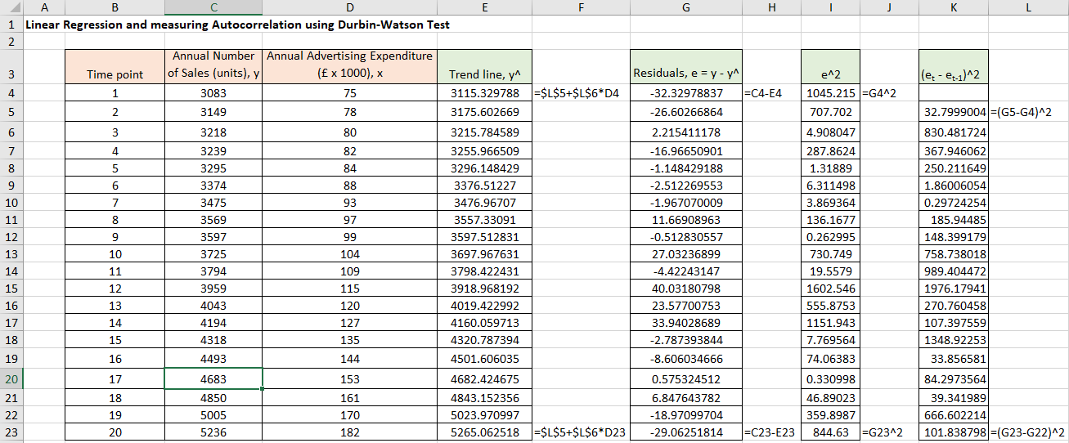

Figure 2 Excel solution for Durbin-Watson test (part 1/2)

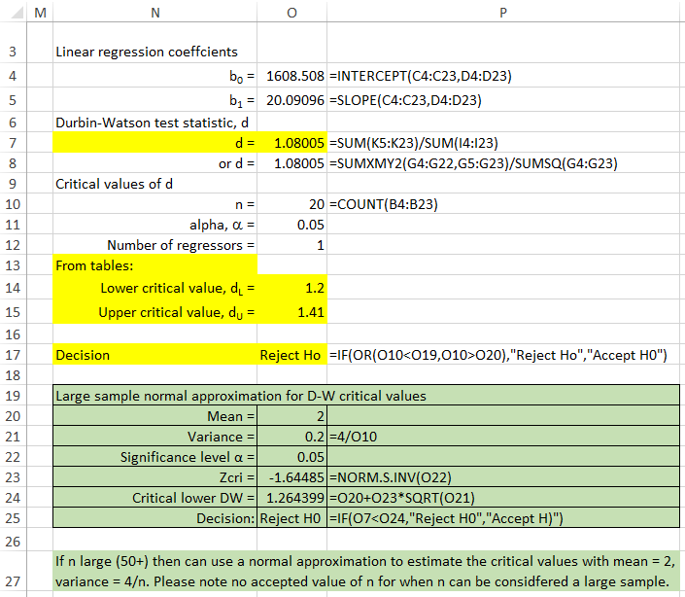

Figure 3 Excel solution for Durbin-Watson test (part 2/2)

**SPSS solution**

Input data into SPSS

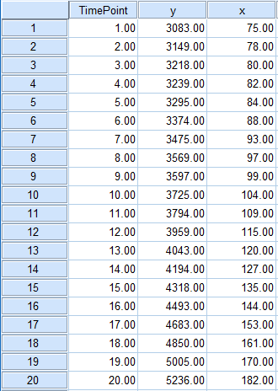

Figure 4 SPSS Data

Run test

Analyze > Regression > Linear

Transfer dependent variable y to the Dependent Variable box

Transfer predictor variable x to the Independent (s) Variables box

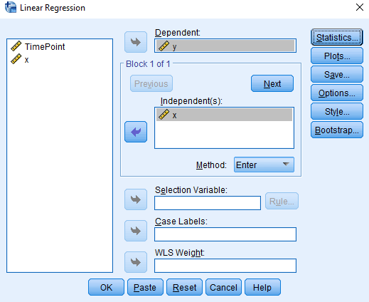

Figure 5 SPSS Linear Regression menu

Click on Statistics and choose Durbin-Watson test

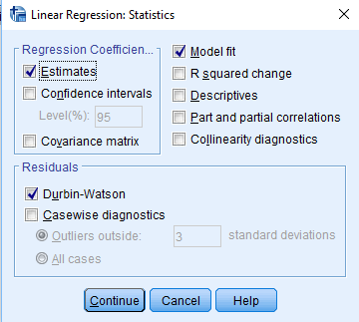

Figure 6 SPSS Linear Regression Statistics menu

Click on Continue

Click on OK

SPSS output

From the SPSS solution, we obtain the model statistics.

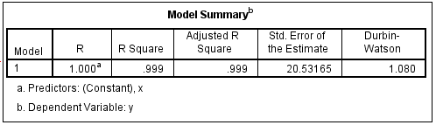Figure 7

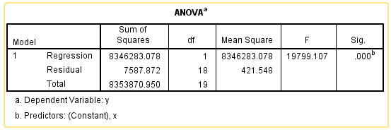Figure 8

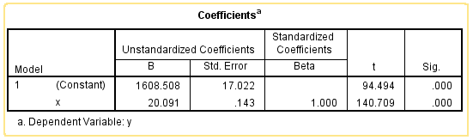Figure 9

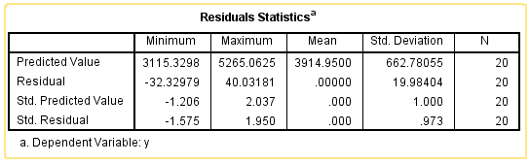Figure 10